Wrapper classes
____________________________________________________________________________________

Q. What are wrapper classes?
________________________________________________________________________
Wrapper class’s inbuilt classes in java which is used for perform conversion
There are two types of conversion in JAVA
_____________________________________________________________
Primitive Conversion: primitive conversion means those conversion perform between simple data type or normal data type called as primitive conversion
Like as int to float , float to int etc
There are two types of primitive types of conversion
_______________________________________________________________________________
Implicit conversion: implicit conversion means those conversion perform automatically by compiler called as implicit conversion
Normally when we put the larger type of data at left hand side and smaller type of data at right hand side then compiler is able to perform conversion automatically called as implicit conversion
Example of implicit conversion
__________________________________________________________________
long a;
int b=100;
a=b;//implicit conversion
Explicit conversion: those conversion perform manually by programmer called as explicit conversion means when we put the smaller type of data at left hand side and larger type of data at right hand side then compiler is unable to perform conversion internally then programmer has responsibility to perform conversion manually called as explicit conversions.
Example:
int a;
long b=100;
a=(int)b; //unable to perform conversion automatically need to perform conversion externally
//called as explicit conversion

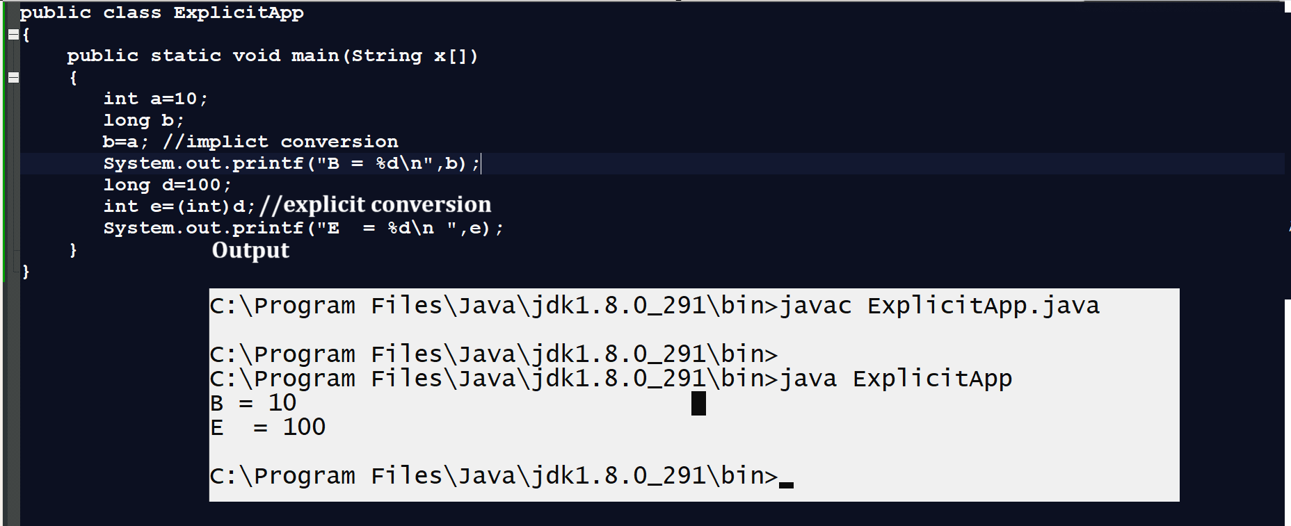
Implicit and explicit conversion get failed when we try to convert referential value in to primitive or primitive value in to referential
_____________________________________________________________________________
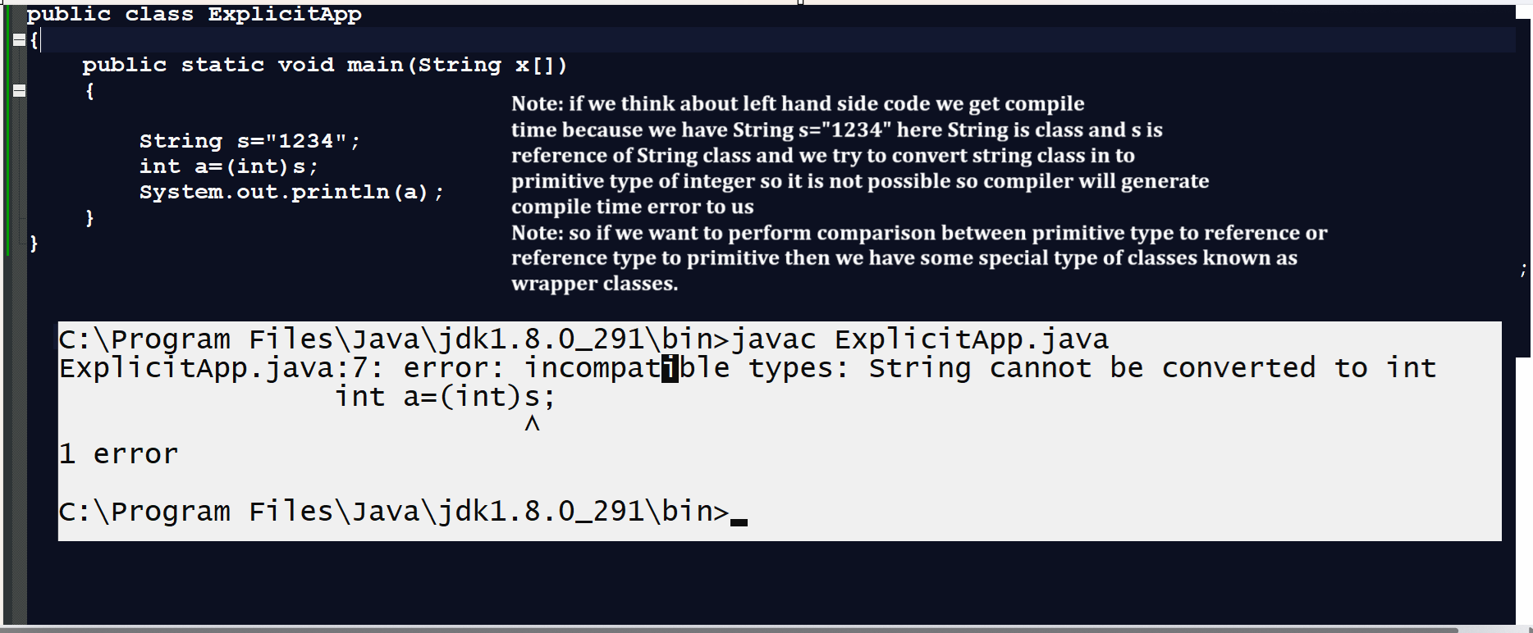
Note: the major goal of wrapper class is perform conversion between primitive to reference and reference to primitive.

Wrapper class Hierarchy
____________________________________________________________________________
If we want to work with wrapper classes in java we have following class hierarchy
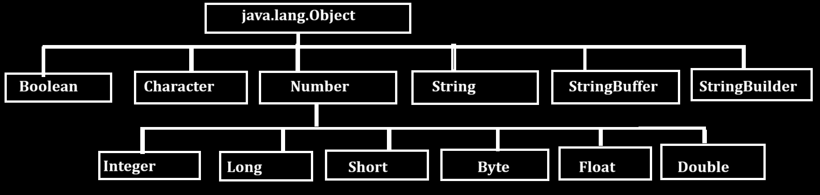
Above diagram indicate it is wrapper class hierarchy

There are two types of conversion present in wrapper classes
__________________________________________________________________________________
Auto boxing: Autboxing means if we convert any primitive value in to reference value called as auto boxing.
Example:
int a=100;
Integer b=a; //auto boxing.

Auto unboxing: auto unboxing means if we convert any referential value in to primitive type of value called as auto unboxing.
Example
Integer a=100;
int b=a;// auto unboxing.

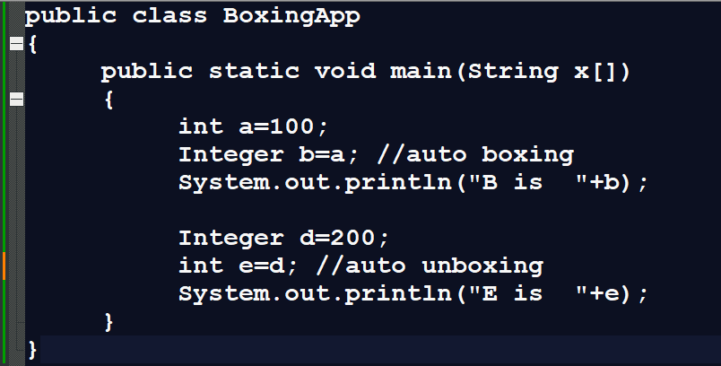
Auto boxing and auto unboxing get failed in some cases means some time if we have different type of primitive or different type of reference then auto boxing and auto unboxing get failed shown in following code.
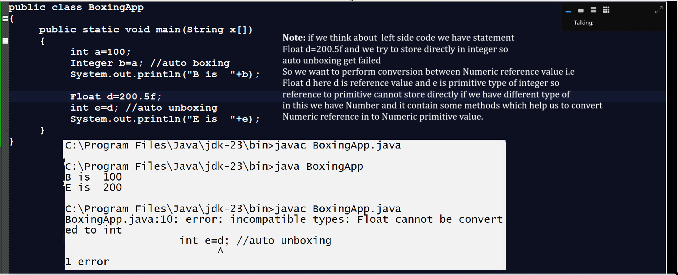
Now we want to discuss about Number class

Q. What is Number class?
_______________________________________________________________________________

Number class is abstract class and it contain some abstract methods knows as xxxValue() methods which help to us perform conversion between numeric reference value to numeric primitive type of value.

Methods of Number class
_____________________________________________________________________________
public abstract int intValue(): this method is used for convert any type of Numeric reference in to primitive type integer value.
Example: we want to convert float to int, double to int, long to int using int intValue() method

Example with source code
public class BoxingApp
{
public static void main(String x[])
{
Float a=5.4f;
Double b=5.4;
Long l=100L;

int c=a.intValue(); //convert float to integer
int d=b.intValue();//convert double to integer
int e=l.intValue();//conovert long to integer

System.out.println("C is "+c);
System.out.println("D is "+d);
System.out.println("E is "+e);
}
}
Output
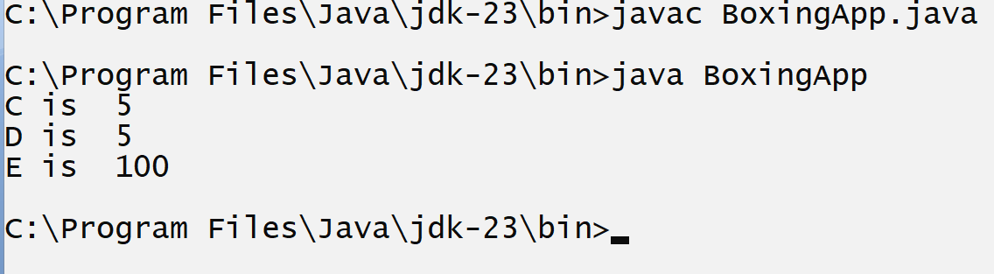
public abstract long longValue(): this method is used for convert any Numeric value to long type

Example with source code
public class BoxingApp
{
public static void main(String x[])
{
Float a=5.4f;
Double b=5.4;
Integer l=100;

long c=a.longValue(); //convert float to long
long d=b.longValue();//convert double to long
long e=l.longValue();//conovert integer to integer

System.out.println("C is "+c);
System.out.println("D is "+d);
System.out.println("E is "+e);
}
}
Output
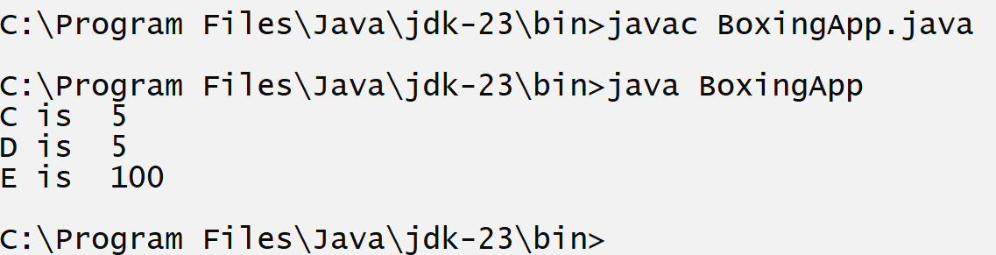
public abstract float floatValue(): this method is used for convert any Numeric reference value to float type.
public abstract double doubleValue(): this method is used for convert any Numeric reference to double value.
public byte byteValue():Convert any Numeric value to byte value.
public short shortValue(): Convert any Numeric value to short value.

Now we want to discuss about the valueOf() method
_______________________________________________________________________________
valueOf() method is used for convert any primitive type of value in to reference type and it is static method present in every wrapper class

Example: we want to convert integer primitive to Float reference, and string reference

Example with source code
public class BoxingApp
{
public static void main(String x[])
{
int a=100;
Float f=Float.valueOf(a);//convert int primitive to float reference
String s=String.valueOf(a);//convert int primitive to string reference.
Double d=Double.valueOf(a);//convert int primitive to double reference
Long l =Long.valueOf(a);//convert int primitive to long reference.
System.out.println("Float is "+f);
System.out.println("String is "+s);
System.out.println("Long is "+l);
System.out.println("Double is "+d);
}
}

parseXXX() method : this method is used for convert any string value to primitive type and it is static method present in every class and this method may be generate NumberFormatException to us if string any non numeric value
Example: suppose consider we have String s=”12345” here 12345 is integer but present in the form of String and we want to convert that value in to integer,float,long then your code look like as
Example with source code.

public class BoxingApp
{ public static void main(String x[])
{
String s="12345";
int a= Integer.parseInt(s);
float b=Float.parseFloat(s);
double d=Double.parseDouble(s);
System.out.println("integer a is "+a);
System.out.println("float b is "+b);
System.out.println("double d is "+d);
}
}
Output
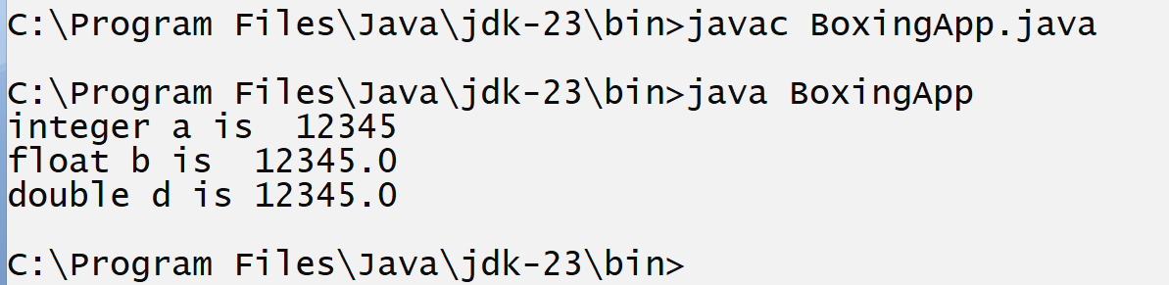

Note: if String contains non numeric value then there is possibility of NumberFormatException at run time.

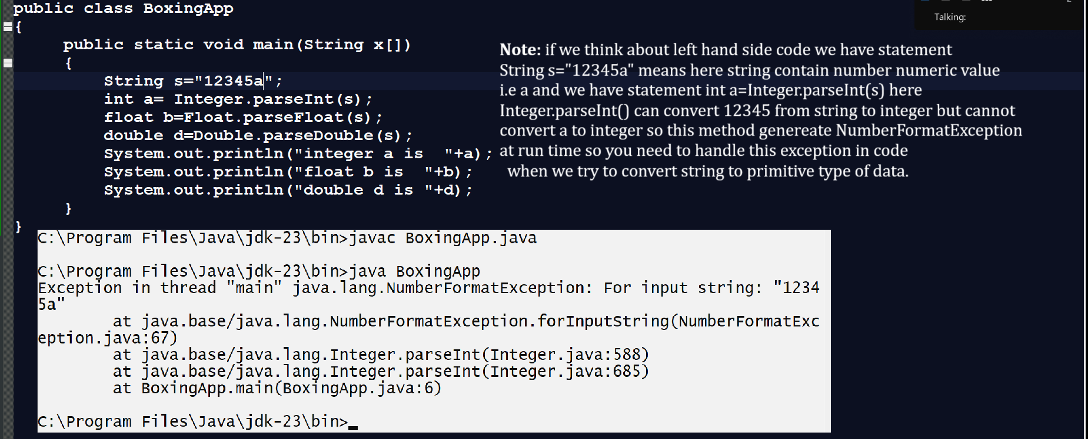

Example with NumberFormatException handling
public class BoxingApp
{
public static void main(String x[])
{
try{
String s="12345a";
int a= Integer.parseInt(s);
float b=Float.parseFloat(s);
double d=Double.parseDouble(s);
System.out.println("integer a is "+a);
System.out.println("float b is "+b);
System.out.println("double d is "+d);
}
catch(NumberFormatException ex)
{ System.out.println("Error is "+ex);
}
}
}
Output
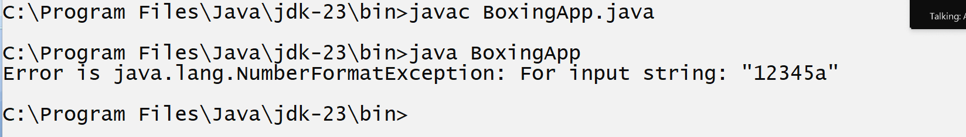

String toString(): this method is used for convert any java object in to string format.

Example: we want to convert integer object in to string format
public class BoxingApp
{
public static void main(String x[])
{
Integer a=100;
String s=a.toString(); //convert integer to string.
System.out.println(s);
}

}
Output
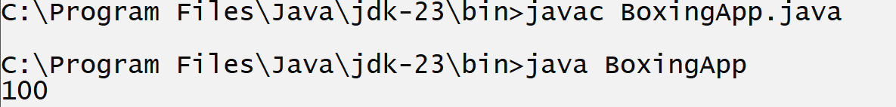

Now we want to discuss about String, StringBuffer and StringBuilder classes in JAVA
______________________________________________________________________________
String: String is a immutable class of java
Q. What is immutable?
________________________________________________________________________
Immutable means once we initialize value cannot modify later called as immutable classes in JAVA.
Means if we think about string in java if we any perform any operation on String then original string cannot modify generate new string every time called as immutable classes in JAVA.

If we want to work with String we have two ways to create String object?
______________________________________________________________________
a) Using initialization Technique
Syntax : String ref=”value”;
Example: String s=”abc”;
b) Using new keyword.
Syntax: String ref = new String(“value”);
Example: String s = new String(“abc”);

Example with source code
public class StringApp
{
public static void main(String x[])
{
String s="abc";
String s1 = new String("abc");
System.out.println("Using initialization "+s);
System.out.println("Using new keyword "+s1);
}
}
Output
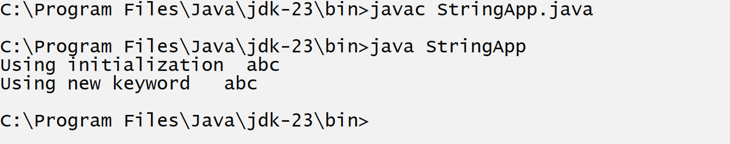

Q. what is difference between string creation using initialization and using new keyword?

Referential Conversion: referential conversion means those conversion perform between object called as referential conversion

